Social media policy template
A social media policy will help you set social media rules and expectations in your workplace. It will also help you to manage incidents with social media.
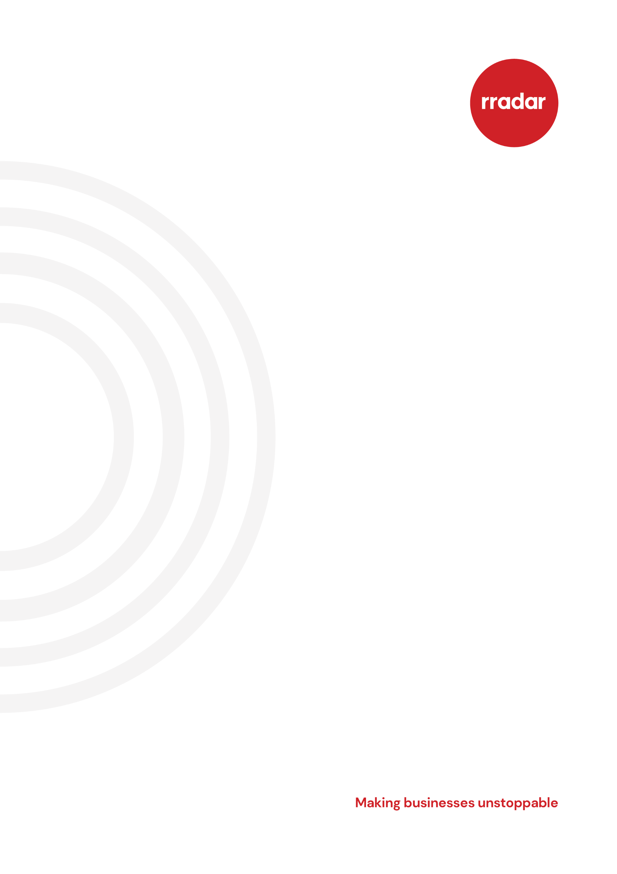
We have created a social media policy template that you can adapt to suit your company’s needs.

How to use this template
Adapt this template to suit your business’ needs.
Here are a few things about this template that you need to know:
- any [text in yellow highlight] is where you should insert information specific to your business
- where there are options, for example, [option 1] or [option 2], select the best option for your business - if no options are suitable, insert something to suit your business
- in the footer of the template, you will find a copyright symbol and rradar’s name - you need to remove this
- when you are finished adapting this template, delete this cover sheet

[Insert organisation name] social media policy

- Purpose of the policy

This policy sets out [insert organisation name]’s expectations of employees when using social media.

- Scope of the policy

This policy applies to all employees, including:

- those who work part-time
- those on fixed-term contracts
- volunteers
- contractors
- temporary and supply staff
- affiliates

- Roles and responsibilities

- senior managers have overall responsibility for this policy
- line managers are responsible for applying this policy consistently
- employees are responsible for following this policy
- [insert name] is responsible for reviewing this policy once a year or where there has been significant changes
- [insert name] is responsible for informing employees about any changes to this policy

- Definition of social media

Social media is defined as websites or applications that allow the sharing of ideas, thoughts and information through virtual networks and communities.

For example:

- Facebook, including Facebook Messenger
- Instagram
- X (formerly known as Twitter)
- TikTok
- YouTube
- WhatsApp
- LinkedIn

This list is not exhaustive.

- Personal use of social media

[Option 1]

Employees are not allowed to access their personal social media accounts on their own or on company devices during work time.

[Option 2]

Employees are allowed to occasionally access their personal social media accounts on their own devices. For example, they use it during lunchtime and breaks. The use of social media must not interfere with their role. Any use of social media must comply with this policy.

- Business use of social media

Your job description will state if you are required to use company social media and, if so, what accounts you will manage.

When using company social media you must:

- access the company accounts through company devices, not your personal devices
- only use social media accounts set up and approved by the company - you must not set up any other accounts on behalf of the company
- follow this policy when posting on social media

- Responsible use of social media

When using social media (either through personal or business accounts) You must not:

- harass, bully, victimise or discriminate against other employees
- breach any legislation - for example, the Equality Act 2010 and the Data Protection Act 2018
- breach company policies or contractual obligations
- breach any copyright belonging to the company - this includes when signposting and linking to content
- disclose any intellectual property belonging to the company
- bring the company into disrepute
- damage the company’s interests

If you disclose that you are an employee of this organisation on your personal social media accounts, you must make it clear that your postings are reflective or your own views and do not represent the company. This point will be emphasised to employees during their induction and in relevant training.

- Consequences of not following this policy

Any behaviour that that is not in line with this policy will be dealt with under the company disciplinary policy.

You should be aware that if actions on social media are considered gross misconduct, this could lead to your dismissal. This is the case even if the behaviour is related to a single post, or a post that was made some time ago.

If an employee wishes to make a complaint against another employee because of something on social media, they should discuss it with their line manager and follow the company grievance procedure, which should be read by all staff as part of their induction.

