Template sexual harassment risk assessment

The Employment Rights Act 2025 introduced new liabilities for employers relating to sexual harassment prevention. Employers must take ‘all reasonable steps’ to prevent sexual harassment and will be directly liable if they don’t do so. Performing a risk assessment that addresses sexual harassment-specific risks is one way businesses can demonstrate they are taking steps to prevent it.
We have created a sexual harassment risk assessment template that you can download and adapt to suit your company’s needs.
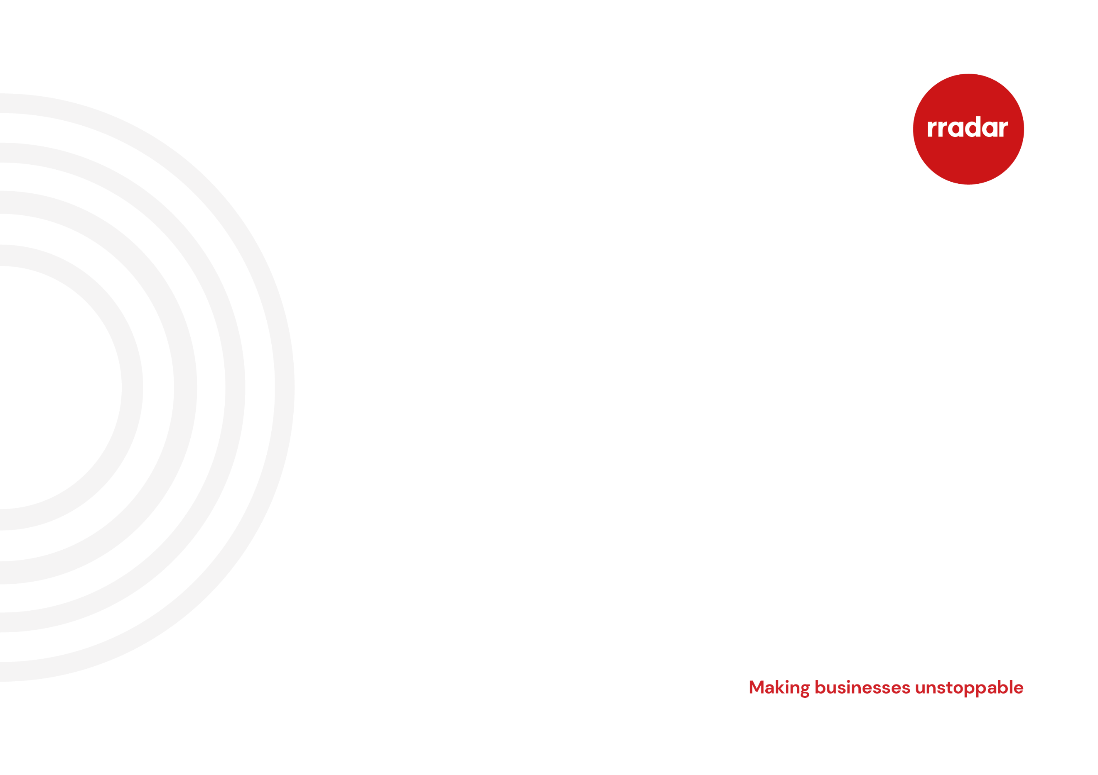
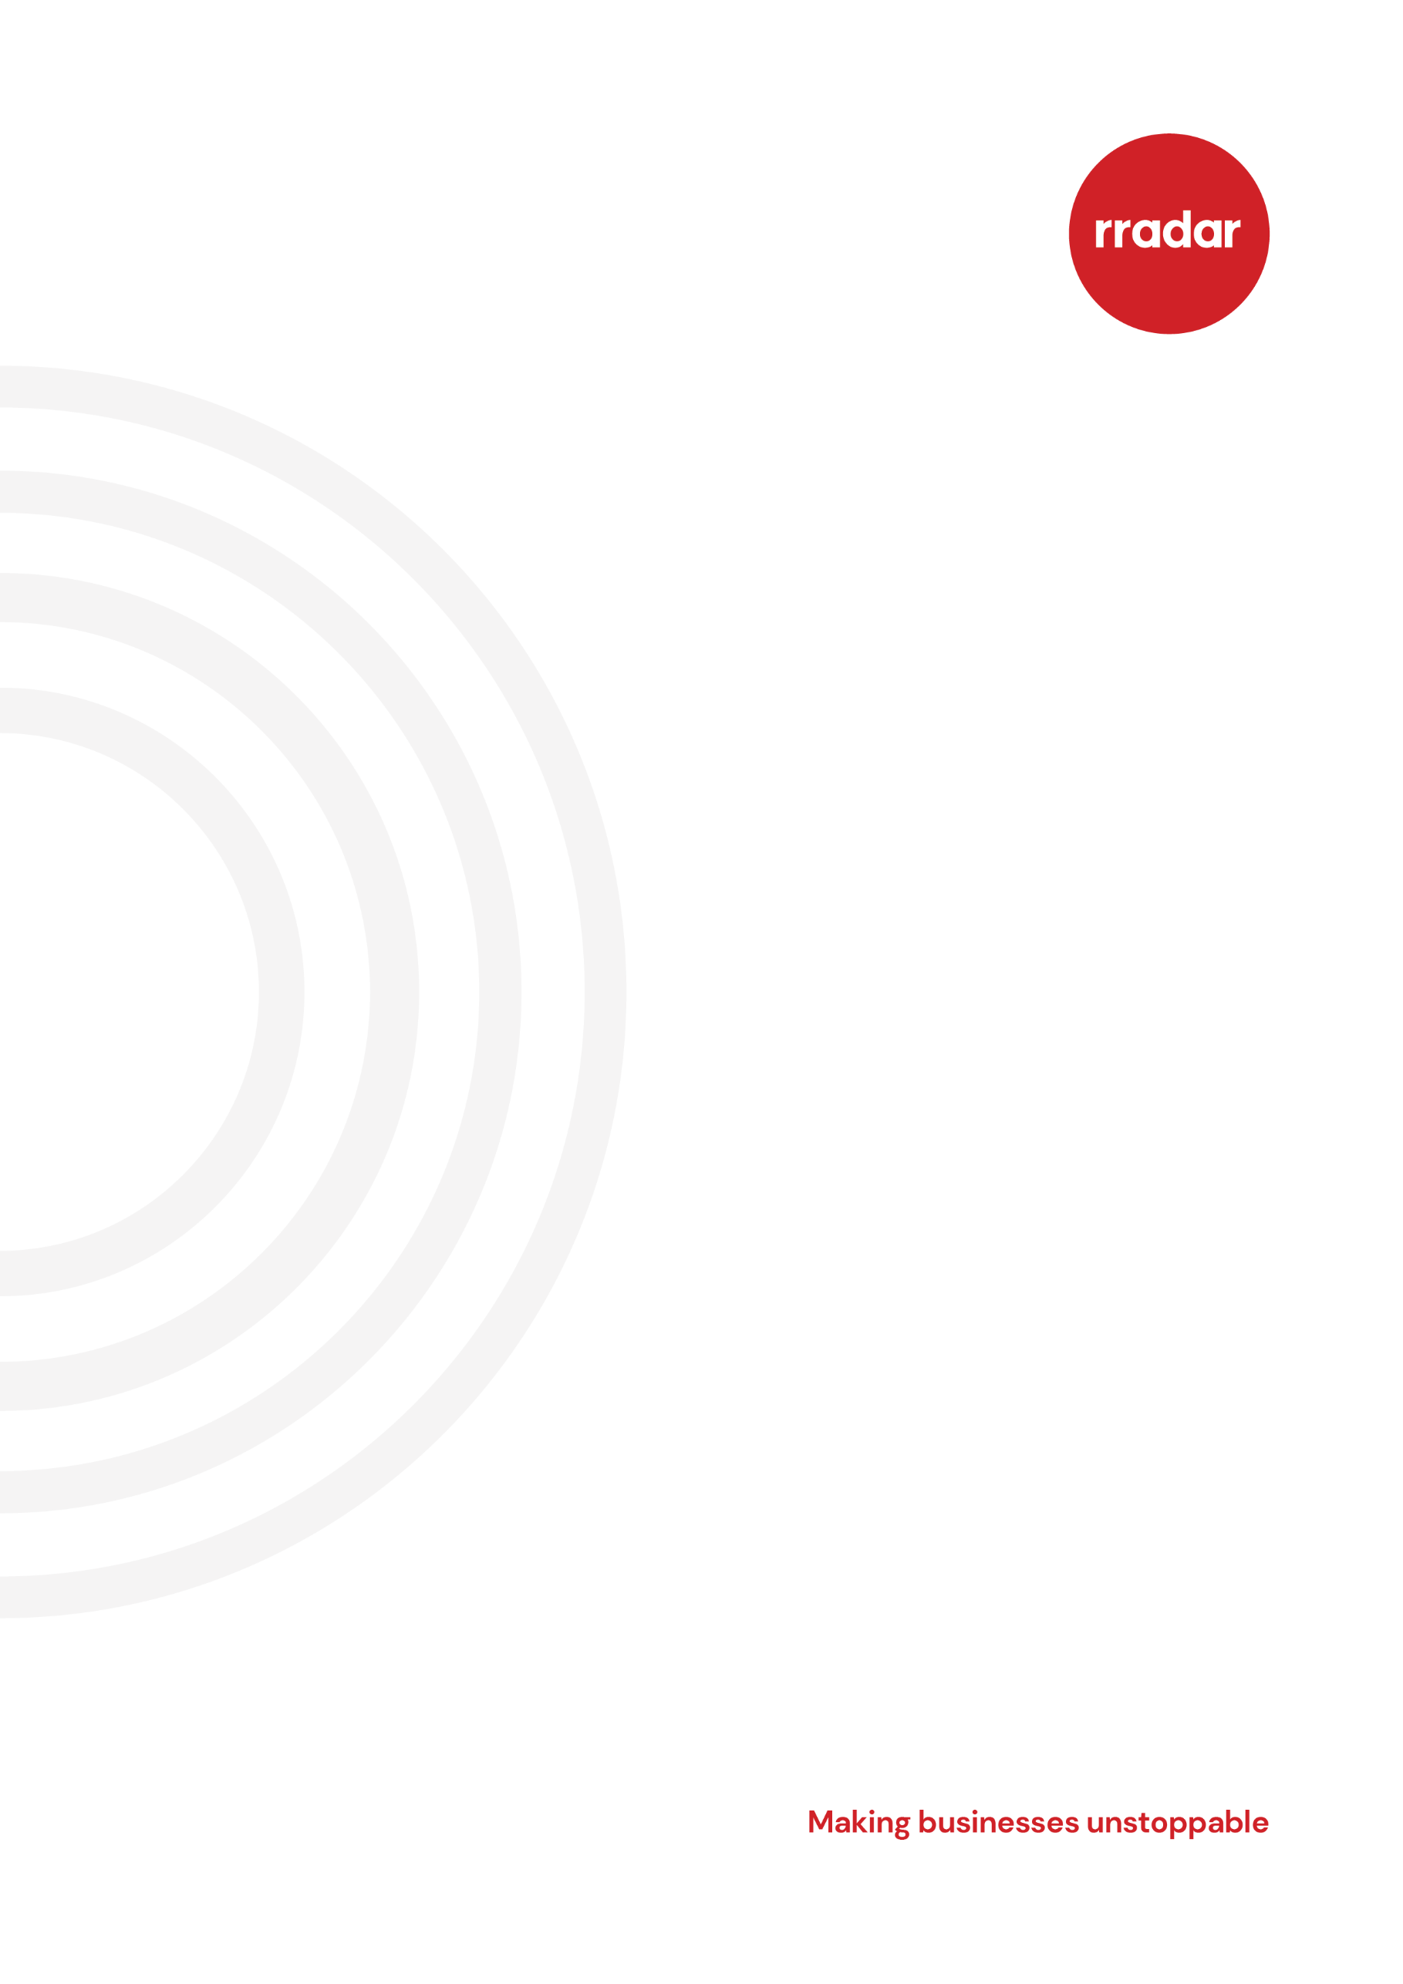

How to use this template
Adapt this template to suit your business’ needs.
Here are a few things about this template that you need to know:
- any [text in yellow highlight] is where you should insert information specific to your business
- where there are options, for example, [option 1] or [option 2], select the best option for your business. If no options are suitable, insert something to suit your business
- in the footer of the template, you will find a copyright symbol and rradar’s name. You need to remove this
- when you are finished adapting this template, delete the cover sheets
Our risk assessment templates are provided as a guide only. Every business is different, so you must review, amend and adapt this document to fit your own circumstances and activities. The final document should reflect your specific risks and circumstances.
The template has been pre-populated with some common risks and control measures. Additional risks and control measures that haven’t been captured in the template can be added using the extra boxes provided.
Once the risks and control measures have been identified, the likelihood and severity ratings must be calculated. The total risk score is the likelihood multiplied by the severity. The higher the number, the more control measures needed. When scoring, consider the frequency of past events and any other historical information.

Score | Likelihood | Severity
1 | Very unlikely. Once in 100 years | Minor. No injury or adverse impact.
2 | Unlikely. Once in 10 years | Minor. Inappropriate comments, gestures or unwanted conduct.
3 | Likely. Once a year | Major. Minor impact or consequence.
4 | Very likely. 10 times a year or monthly | Major. Serious impact or consequence.
5 | Certain. 100 times a year or twice weekly | Major. Foreseeable risk of sexual assault.

Total score rating
1-4 = low | 5-9 = medium | 10-15 = high | 16-25 = very high
Continue with current control measures, monitor regularly | Requires attention to reduce the rating, monitor regularly. Further control measures needed | Requires immediate attention to reduce the rating. Further control measures needed | Immediate action must be taken to reduce the risk, do not continue. Further control measures needed

[Insert organisation’s name]’s risk assessment for sexual harassment
Assessor’s name: |  | Signature: |  |  | Date: |  |  |  |  | Reference:
Manager: |  | Signature: |  |  | Date: |  |  |  |  | Location:
1.Hazards |  | 2.Who might be harmed and how? |  | 3.Evaluate the risk with current controls in place | Risk rating  [See guidance notes above to complete this section] |  |  | 4.Record of findings and further action
 |  |  |  | 3.Evaluate the risk with current controls in place | Likelihood | Severity | Total | Further action(s) needed to reduce risk so far as is reasonably practicable |  |  | Date action due | Date action complete
 | Employees and contractors do not understand what constitutes sexual harassment | All employees, contractors and clients/customers |  | Employees and contractors are given sexual harassment training as part of their induction.  Refresher training is provided annually.  Our sexual harassment policy has a clear definition of sexual harassment. |  |  |  | Manager-specific training.
 | Employees and contractors do not know how to report sexual harassment | All employees and contractors |  | Our sexual harassment policy, grievance policy and employee training explain how employees can report sexual harassment.
 | The workplace culture | All employees, contractors and clients/customers |  | We adopt a zero-tolerance approach to sexism and sexual harassment in the workplace. This includes sexual harassment directed at employees, contractors or customers. |  |  |  | Review recruitment processes to ensure they are not discriminatory.
 | Night working, lone working and out-of-hours working | All employees and contractors |  | Our night and lone working policies set out measures to ensure that:  - managers routinely ‘check in’ with their direct reports where they work irregular hours  - workers know how to protect themselves and report risks
 | Business entertainment, socialising and alcohol consumption | All employees and contractors |  | Our business entertainment policy sets limits on alcohol consumption.  Our disciplinary policy sets out expected standards of behaviour during business entertainment and office parties, and the consequences of falling short of those expectations.
 | Customer behaviour | All employees and contractors |  | Our policies and training set out how employees should respond to inappropriate customer behaviour and how employees are supported if they are subject to inappropriate customer behaviour. |  |  |  | Manager-specific training.
 | Social media | All employees and contractors |  | Our social media managers receive role-specific training that includes how to respond to sexist and harassing comments on company social media accounts.  Our disciplinary policy covers expected behaviour of employees when using their own social media accounts.
 | Company policies | All employees and contractors |  | Where relevant, company policies reference our sexual harassment policy. For example, our IT and social media policies make it clear that company systems and tools must not be used to sexually harass someone or for any other inappropriate behaviour.
 | [insert risk specific to your company/industry] | [complete according to the specific risk identified] |  | [insert measures in place to minimise risk]
 | [insert risk specific to your company/industry] | [complete according to the specific risk identified] |  | [insert measures in place to minimise risk]
 | [insert risk specific to your company/industry] | [complete according to the specific risk identified] |  | [insert measures in place to minimise risk]
Review in 12 months or after an incident or when something changes |  |  | Reviewer | Reason | Manager name |  |  |  | Signature |  |  | Date

